# Walk Through Assignment Using Text of My Choice

## Objective

Walk through assignment with YouTube videos linked in the discussion to get a better understanding of the MapReduce function in Cloudera. I know this isn’t part of the assignment to turn in but I wanted to document this and put with my assignment for save keeping.

1. Download a text of choice, I chose Brave New World by Adlous Huxley, and bring make sure it is part of your downloadable materials in the terminal.

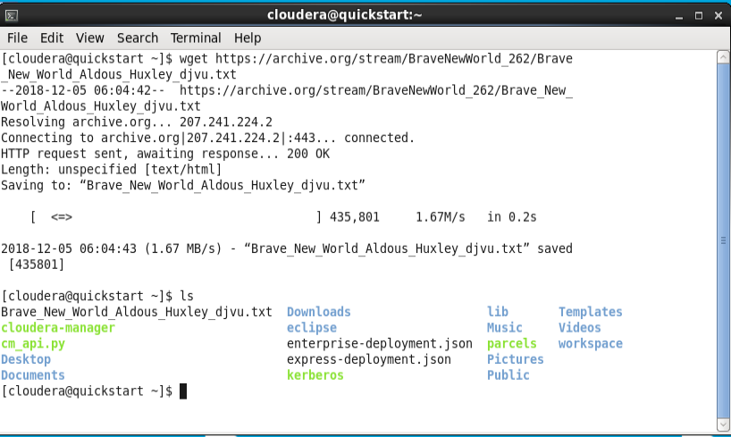

1. Cut out unnecessary text from the text document that you are using.

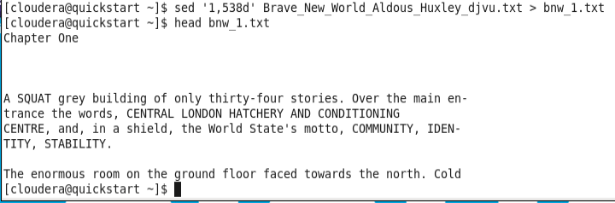

1. Next, cut out the text that is hanging at the bottom.



1. Next we will set up our text similar to the exercise to turn in, but instead of using input.txt, use the text from Brave New World.
2. Code: ./counts.py > bnw_2.txt

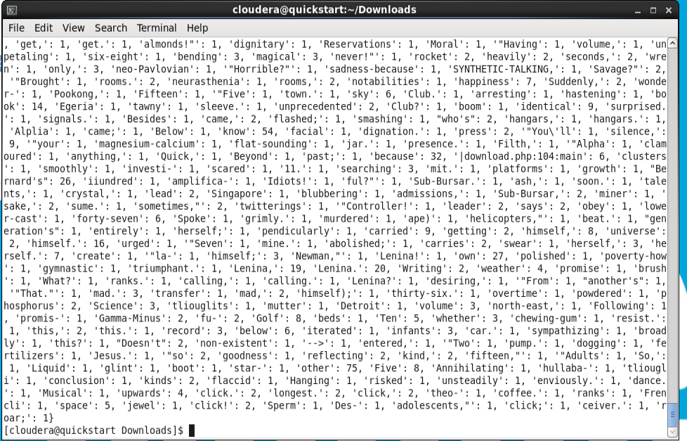

1. Code: ./mapper.py > bnw_2.txt

